



**Revision History**

| **Date** | **Version** | **Author** | **Change Description** |
| --- | --- | --- | --- |
| 17/09/2024 | 0.1 | dongnt | Initial creation |
| 05/11/2024 | 0.2 | linhtly | Update Diagram |
| 06/11/2024 | 0.3 | linhtly | Update Business Requirement |
| 19/12/2024 | 0.4 | khoapnm | Complete BRD |
|  |  |  |  |

**Approval**

| **Date** | **Version** | **Approver Name** | **Position** |
| --- | --- | --- | --- |
|  |  |  |  |
|  |  |  |  |
|  |  |  |  |
|  |  |  |  |
|  |  |  |  |
|  |  |  |  |

**Table of Contents**

1 Objective and Scope 3

2 Business Requirement 3

2.1. Application Overview 3

2.2. Domain Model 4

2.2.1. Diagram 4

2.2.2. Domain Objects Description 5

2.3. Workflow 6

2.4. Use Cases and Actors 8

2.4.1. Diagram 8

2.4.2. Description of Actors 8

2.4.3. Description of Use Cases 9

2.5. Security Matrix 9

2.6. Change Requirement 10

3 Appendix 11

3.1. Glossary 11

3.2. Open Issues 11

# Objective and Scope

The objective of the Supply Chain Management Support System is to develop an integrated, scalable, and efficient digital solution for automating and optimizing the processes involved in supply chain operations. This project aims to streamline tasks such as partner and product management, inventory control, warehouse operations, transportation logistics, and comprehensive reporting, ensuring improved operational efficiency, data accuracy, and user experience.

**Authentication & Security**:

* Implementation of a robust authentication system, including user sign-up, login, password reset, and profile management to secure user data.

**Partner Management**:

* Creating, editing, deleting, and viewing partner information efficiently.
* Differentiating between various types of partners for tailored management.

**Product Management**:

* Administering product categories by allowing CRUD (Create, Read, Update, Delete) operations to maintain up-to-date catalogs.

**Warehouse Management**:

* Managing warehouse operations, including inventory tracking, regular audits, and asset checks.
* Facilitating warehouse stock and logistics information for real-time visibility.

**Transportation Management**:

* Managing transportation details, vehicle information, and parking slot allocation for optimal logistics planning.
* Assigning and coordinating drivers and vehicle routes efficiently.

**Logistics Management**:

* Managing order creation, updates, and cancellations with relevant logistics workflows.
* Facilitating logistics coordination and monitoring delivery schedules and updates.

**Reporting**:

* Generating detailed reports to assist in operational decision-making, with data visualizations and performance metrics.

**User Role Management**:

* Assigning roles and permissions, updating user roles, and managing user profiles to ensure system access control.

# Business Requirement

* As an admin, I want to create a new warehouse, edit a warehouse information, delete a warehouse information.
* As a warehouse manager, I want to view all products in the warehouse, check the asset list of inventory, and update the actual status of the warehouse for the day.
* As an admin, I want to view the status report for the selected date.
* As a logistic manager, I want to create and edit new inventory entries.
* As a logistics manager, I want the system to automatically create an entry when a trip is scheduled
* As a warehouse manager, I want to confirm receipt of shipments when they arrive.
* As an admin, a warehouse manager, a logistic manager of a warehouse, I want to view the import order list and export order list .
* As a user, I want to create an import order to record details of products entering the warehouse, ensuring accurate inventory management.
* As a user, I want to confirm an import order to update the inventory once products arrive at the warehouse.
* As a user, I want to view a list of import orders to monitor their status and details for effective tracking.
* As a user, I want to create an export order to manage products leaving the warehouse and ensure proper documentation.
* As a user, I want to confirm an export order to ensure products are dispatched and inventory is updated.
* As a user, I want to view a list of export orders to monitor outgoing shipments and their statuses.
* As a user, I want to create an order to process customer requests effectively, confirm an order to move it to the next processing stage.
* As a user, I want to view a list of orders to monitor their status and manage customer requests, create a shipment to manage the logistics of delivering orders efficiently.
* As a user, I want to view a list of shipments to monitor their progress and ensure timely deliveries.
* As an <Admin>, I want to <Create partner information>(including Name, Owner, Address, Type(Warehouse, Transport Provider, Supplier,...)) so that I can Store new company partners
* As an <Admin>, I want to <Edit partner information> so that I can Adjust existing partner information in the system
* As an <Admin>, I want to <Delete partner information> so that I can Remove information of inactive or irrelevant partners
* As an <Admin>, I want to <View partner list> so that I can Manage and update partner information
* As an <Admin>, I want to <Create partner type>(including Name,...) so that I can Classify partners (Supplier, Warehouse, Transport Provider,...) and manage access rights for each type
* As an <Admin>, I want to <Edit partner type> so that I can Adjust existing partner type in the system
* As an <Admin>, I want to <View partner type list> so that I can Manage and update partner type
* As an <Admin>, I want to <Create product>(including Name, Price. Supplier, Type, Size, Weight,...) so that I can Categorize products and use them for reports and analysis
* As an <Admin>, I want to <Edit product> so that I can Adjust existing product information in the system
* As an <Admin>, I want to <Delete product> so that I can Remove irrelevant products
* As an <Admin>, I want to <View product list> so that I can Manage and update products
* As an <Accountant>, I want to <View partner list> so that I can Reconcile invoices, calculate revenue, and calculate costs for various services
* As an <Accountant>, I want to <View product list> so that I can Calculate revenue by product and analyze performance of product
* As a <Human Resource>, I want to <View partner list> so that I can Manage and update partner information
* As a <Warehouse Manager>, I want to <View product list> so that I can Manage products in warehouse, manage inventory, and handle goods receipt and delivery
* As a <Logistics Manager>, I want to <View partner list> so that I can Plan transportation plan and select suitable partners
* As a <Logistics Manager>, I want to <View product list> so that I can Adjust plans to meet the requirements of product in orders
* As a <Logistics Manager>, I want to <Create partner information>(including Name, Owner, Address, Type(Warehouse, Transport Provider, Supplier,...)) so that I can Store new company partners
* As a <Logistics Manager>, I want to <Edit partner information> so that I can Adjust existing partner information in the system
* As a <Logistics Manager>, I want to <Delete partner information> so that I can Remove information of inactive or irrelevant partners
* As a <Sales Staff>, I want to <View partner list> so that I can Find suitable product and service suppliers meeting the customer requirements
* As a <Sales Staff>, I want to <Create product>(including Name, Price. Supplier(Nullable), Type, Size, Weight,...) so that I can Create products that meeting customer requirements
* As a <Sales Staff>, I want to <Edit product> so that I can Adjust products information to meet customer requirements
* As a <Sales Staff>, I want to <Delete product> so that I can Remove irrelevant products
* As a <Sales Staff>, I want to <View product list> so that I can Provide product advice to customers
* As an <Admin>, I want to <Create vehicle information>(including LicensePlate, Driver, TransportProvider, VehicleType, Status) so that I can Store new vehicle information of their own company
* As an <Admin>, I want to <Edit vehicle information> so that I can Adjust existing vehicle information in the system of their own company
* As an <Admin>, I want to <Delete vehicle information> so that I can Remove information of inactive vehicles
* As an <Admin>, I want to <View vehicle list> so that I can Manage and update vehicle information
* As an <Admin>, I want to <Create driver information>(including Name,IDNumber, Email, PhoneNumber) so that I can Store new driver information
* As an <Admin>, I want to <Edit driver information> so that I can Adjust existing driver information in the system
* As an <Admin>, I want to <Delete driver information> so that I can Remove information of inactive drivers
* As an <Admin>, I want to <View driver list> so that I can Manage and update driver information
* As an <Admin>, I want to <Assign drivers by vehicle> so that I can Trace the shipment and ensure transparency
* As a <Transport Manager>, I want to <Create vehicle information>(including LicensePlate, Driver, TransportProvider, VehicleType, Status) so that I can Store new vehicle information of their own company
* As a <Transport Manager>, I want to <Edit vehicle information> so that I can Adjust existing vehicle information in the system of their own company
* As a <Transport Manager>, I want to <Delete vehicle information> so that I can Remove information of inactive vehicles of their own company
* As a <Transport Manager>, I want to <View vehicle list> so that I can Manage and update vehicle information of their own company
* As a <Transport Manager>, I want to <Create driver information>(including Name,IDNumber, Email, PhoneNumber) so that I can Store new driver information of their own company
* As a <Transport Manager>, I want to <Edit driver information> so that I can Adjust existing driver information in the system of their own company
* As a <Transport Manager>, I want to <Delete driver information> so that I can Remove information of inactive drivers of their own company
* As a <Transport Manager>, I want to <View driver list> so that I can Manage and update driver information of their own company
* As a <Transport Manager>, I want to <Assign drivers by vehicle> so that I can Trace the shipment and ensure transparency
* As a <Warehouse Manager>, I want to <View vehicle list> so that I can Track the vehicle status and follow shipment
* As a <Warehouse Manager>, I want to <View driver list> so that I can Track the driver responsible for the vehicle
* As a <Logistics Manager>, I want to <View vehicle list> so that I can Plan for the shipment for customer's orders
* As a <Logistics Manager>, I want to <View driver list> so that I can Track the driver responsible for the vehicle

# Application Overview

The Supply Chain Management Support System will be a web and mobile-enabled application designed for different user roles, including administrators, warehouse managers, vehicle coordinators, sales representatives, accountants, HR personnel, and logistics managers. Key features will include:

* **Authentication**: Ensuring secure access and role-based permissions.
* **Multi-user Environment**: Facilitating collaboration between departments, from warehouse management to logistics and sales.
* **Data Management**: Providing comprehensive modules for managing partners, products, warehouses, transportation, and orders.
* **Reporting and Analytics**: Offering insights through reports to enhance decision-making and operational transparency.
* **User-Friendly Interface**: Optimized for both web and mobile platforms to ensure accessibility and ease of use.

# Domain Model

# Diagram

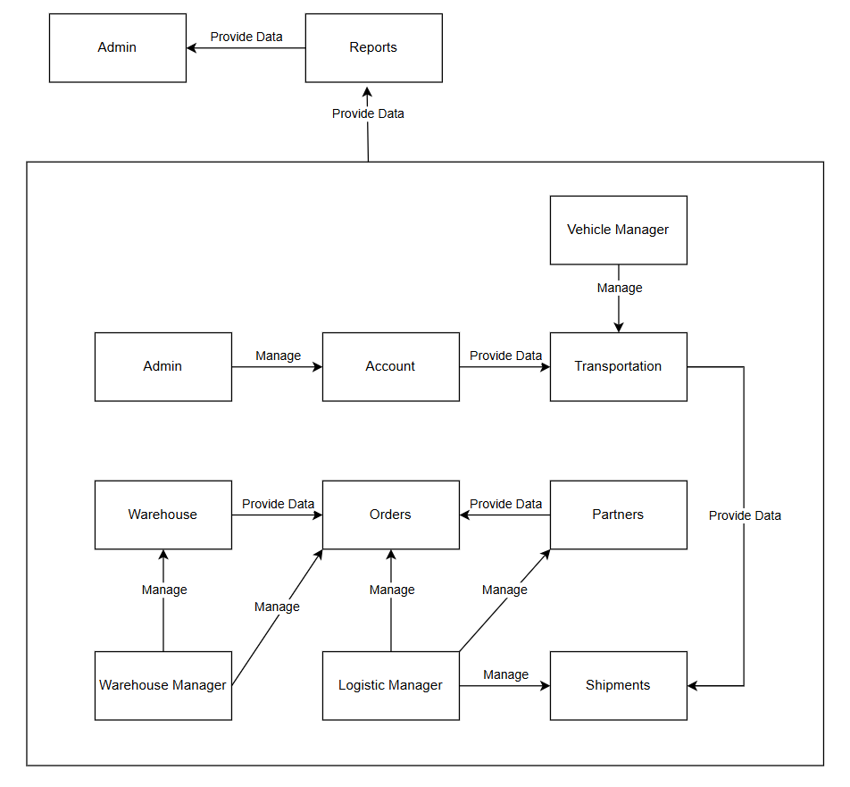

# Domain Objects Description

| # | Object Name | Object Description |
| --- | --- | --- |
| 1 | Admin | An entity with the highest permissions, managing user data, permissions and has full access to all modules. |
| 2 | Reports | The report entity contains aggregated information about inventory products, orders, and transportation |
| 3 | Vehicle Manager | The entity managing the fleet, responsible for managing vehicles, drivers, transporters |
| 4 | Account | The organization entity manages accounts and user groups by type and user information. |
| 5 | Transportation | The transportation entity manages information about vehicles and types of vehicles, driver |
| 6 | Warehouse | The product entity manages basic information about products and inventory |
| 7 | Orders | The orders entity manages information about sales and purchase orders |
| 8 | Partners | The partner entity manages customer and supplier information. |
| 9 | Warehouse Manager | The warehouse manager entity has the rights to create, delete, edit, read functions in Warehouse |
| 10 | Logistic Manager | The logistics manager has the rights to create, delete, edit, read in Orders and Planning, Partners |
| 11 | Shipment | The shipment entity allows for the construction of routes for orders based on destinations and origins, using available warehouses |

# Workflow

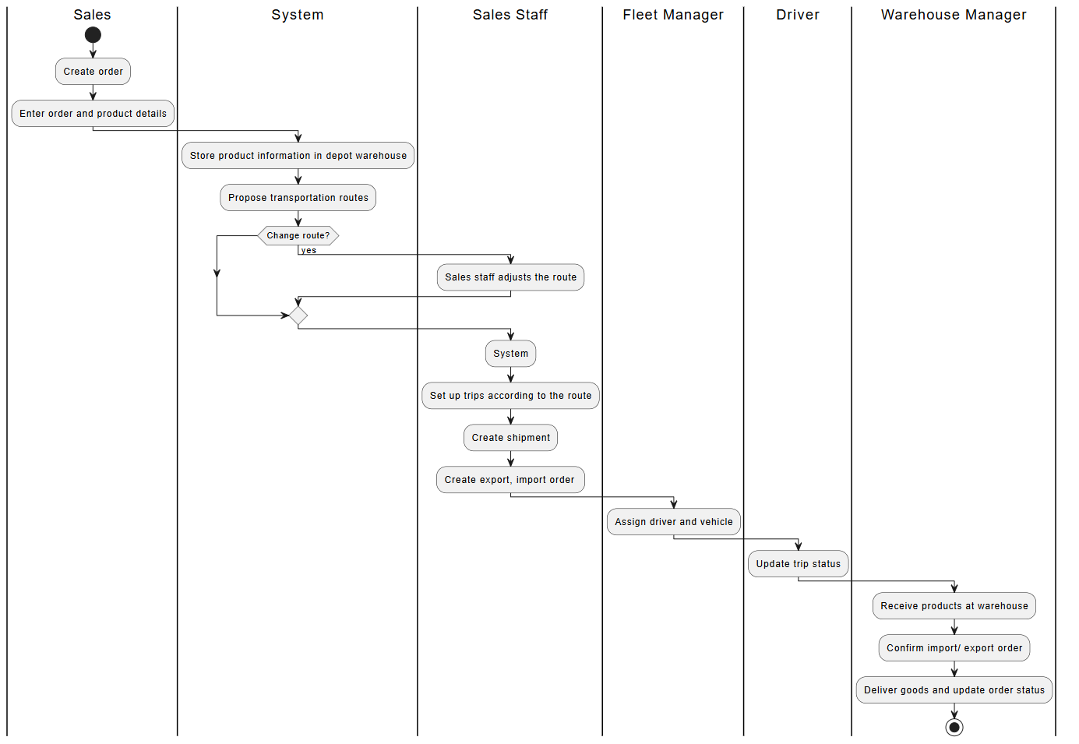

# 

# Use Cases and Actors

# Diagram

# 

# 

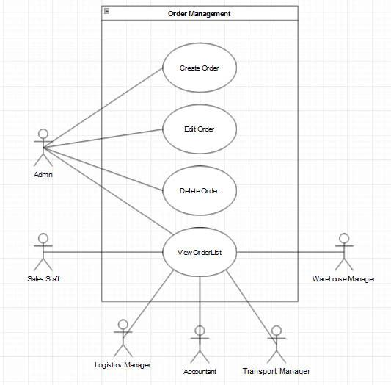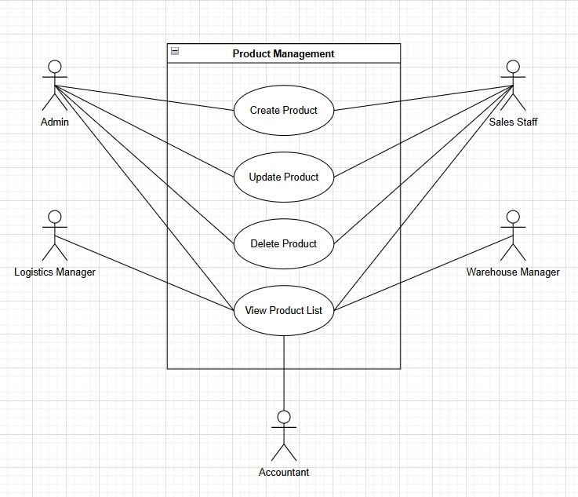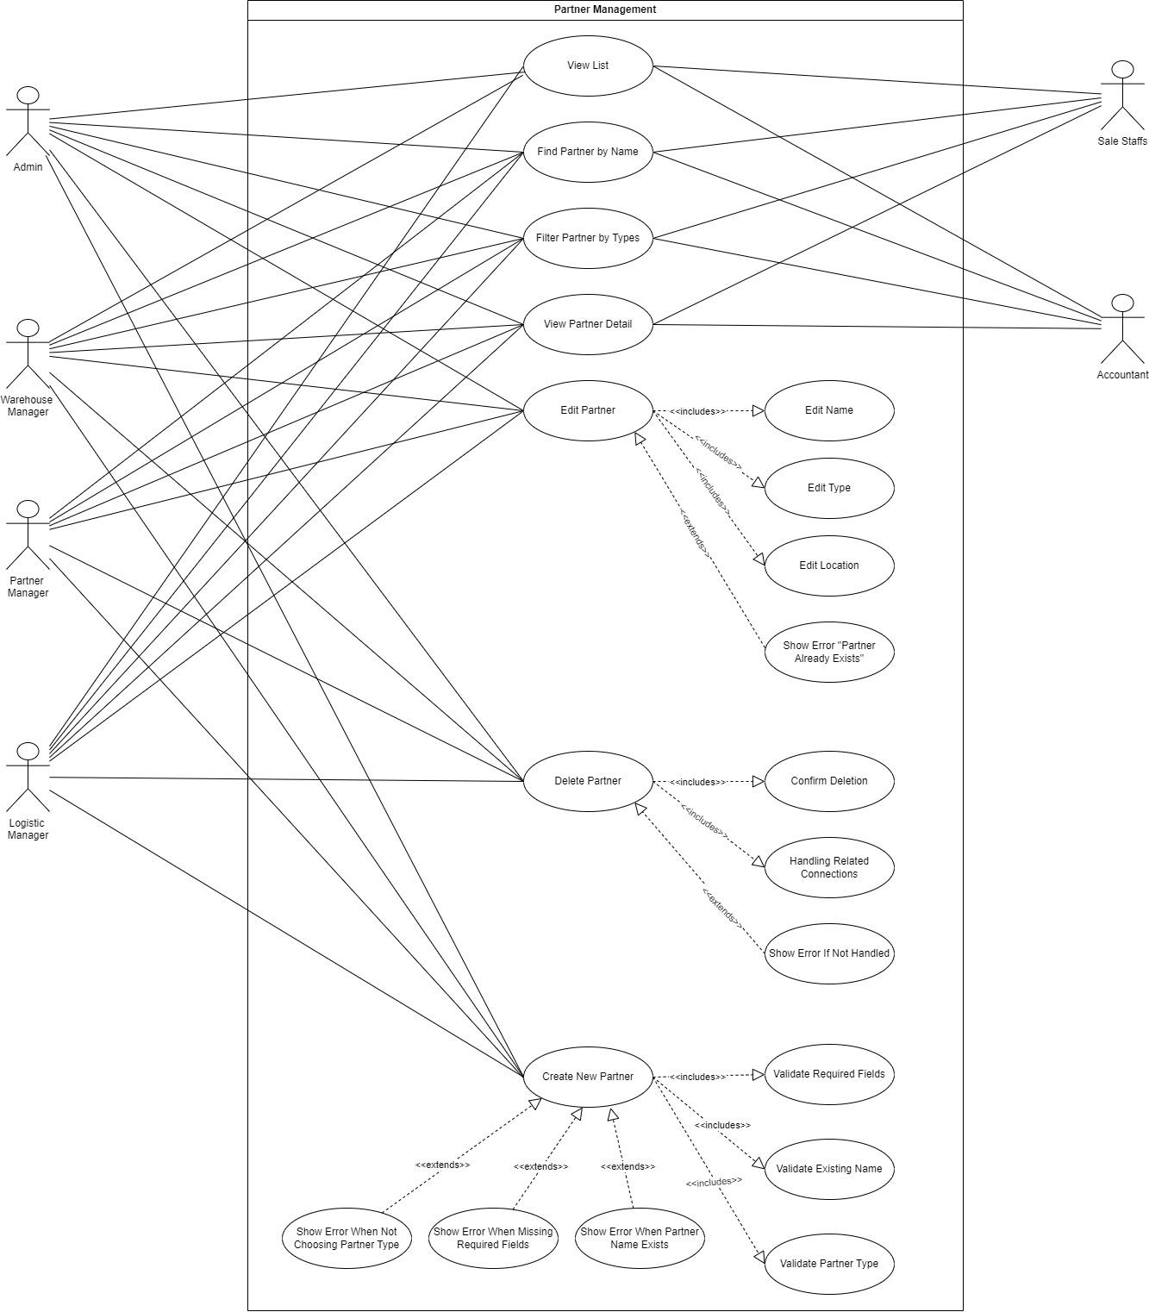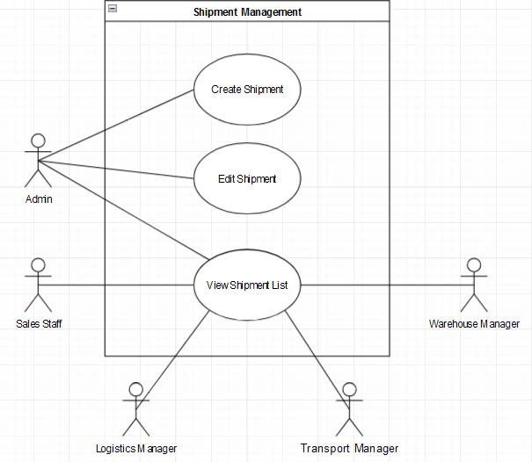

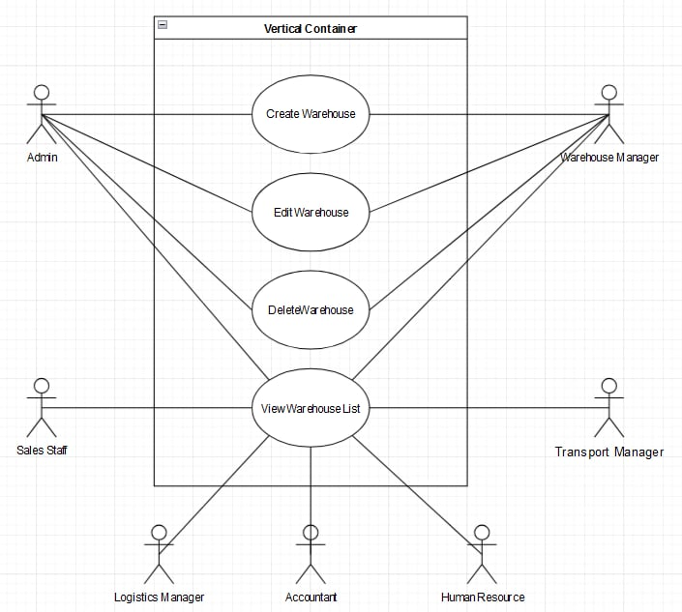

# Description of Actors

| # | Actor Name | Definition |
| --- | --- | --- |
| 1 | Admin | The primary actor responsible for managing core functionalities such as creating, updating, deleting, and viewing records across multiple modules. |
| 2 | Warehouse Manager | Oversees and manages the operations related to warehouses, including inventory and reporting. |
| 3 | Sales Staff | Views lists and accesses specific records needed for sales operations. |
| 4 | Transport Manager | Manages transportation-related tasks, including overseeing shipments and drivers. |
| 5 | Logistics Manager | Handles logistics operations and manages drivers, products, and orders. |
| 6 | Accountant | Manages financial records related to products, orders, and warehouses. |
| 7 | Partner Manager | Oversees partner management, including editing, creating, and deleting partner records. |
| 8 | Warehouse Staff | Assists in warehouse operations such as managing and printing import orders. |
| 9 | Vehicle Manager | Manages and oversees vehicle and driver information. |

# Description of Use Cases

| # | Use Case Name | Definition |
| --- | --- | --- |
| 1 | Create Warehouse | This use case allows Admin and Warehouse Manager to add a new warehouse, including entering all details. |
| 2 | Edit Warehouse | This use case allows Admin and Warehouse Manager to modify existing warehouse information. |
| 3 | Delete Warehouse | This use case allows Admin to remove an existing warehouse record from the system. |
| 4 | View Warehouse List | This use case allows all actors to view the list of warehouses and their relevant information. |
| 5 | Create Shipment | This use case allows Admin to create a new shipment by entering shipment details and specifications. |
| 6 | Edit Shipment | This use case allows Admin to update or change the information of an existing shipment. |
| 7 | View Shipment List | This use case allows all actors to access and review the list of all shipments and their statuses |
| 8 | Create Product | This use case allows Admin and Warehouse Manager to create and add a new product to the system. |
| 9 | Update Product | This use case allows Admin, Sales Staff, and Warehouse Manager to update product details. |
| 10 | Delete Product | This use case allows Admin and Warehouse Manager to remove an existing product from the system. |
| 11 | View Product List | This use case allows all actors to view and browse through the list of products. |
| 12 | View List | This use case allows all actors to view the complete list of partners. |
| 13 | Find Partner by Name | This use case allows actors to search for a partner using their name. |
| 14 | Filter Partner by Types | This use case allows actors to filter partners based on specific categories or types. |
| 15 | View Partner Detail | This use case allows actors to view detailed information about a selected partner. |
| 16 | Edit Partner | This use case allows Admin and Partner Manager to modify partner details, such as name and type. |
| 17 | Delete Partner | This use case allows Admin to remove a partner and manage associated dependencies. |
| 18 | Create New Partner | This use case allows Admin to add a new partner with all required fields and validations. |
| 19 | Create Order | This use case allows Admin to create a new order with detailed information about items and quantities. |
| 20 | Edit Order | This use case allows Admin to update or modify details of an existing order. |
| 21 | Delete Order | This use case allows Admin to delete an order from the system. |
| 22 | View Order List | This use case allows all actors to view and review the list of orders. |
| 23 | View All Products in Warehouse | This use case allows Admin and Warehouse Manager to see a list of all products in the warehouse. |
| 24 | Report Status Daily | This use case allows Warehouse Manager to report the daily status of warehouse operations. |
| 25 | Asset Inventory | This use case allows Accountant and Warehouse Manager to manage and review warehouse assets. |
| 26 | Create Import Order | This use case allows Admin and Warehouse Manager to create an order for importing goods. |
| 27 | Confirm Import Order | This use case allows Admin to confirm the details of an import order. |
| 28 | Cancel Import Order | This use case allows Admin to cancel an existing import order. |
| 29 | Edit Import Order | This use case allows Warehouse Manager to make changes to import order details. |
| 20 | View Import Order List | This use case allows all actors to view the list of import orders and their statuses. |
| 21 | Print Import Order | This use case allows Warehouse Staff to print the details of an import order. |
| 22 | Create Export Order | This use case allows Admin and Warehouse Manager to create an order for importing goods. |
| 23 | Confirm Export Order | This use case allows Admin to confirm the details of an import order. |
| 24 | Cancel Export Order | This use case allows Admin to cancel an existing import order. |
| 25 | Edit Export Order | This use case allows Warehouse Manager to make changes to import order details. |
| 26 | View Export Order List | This use case allows all actors to view the list of import orders and their statuses. |
| 27 | Print Import Order | This use case allows Warehouse Staff to print the details of an import order. |
| 28 | Create Driver | This use case allows Admin and Vehicle Manager to add a new driver, including all relevant details. |
| 29 | Update Driver | This use case allows Admin and relevant managers to modify an existing driver’s information. |
| 30 | Delete Driver | This use case allows Admin to remove a driver from the system. |
| 31 | View Driver List | This use case allows all actors to view the list of drivers and their details. |

# Security Matrix

| Actor  Function | Admin | Warehouse Manager | Vehicle Manager | Sale | Accountant | Human Resource | Logistic Manager |
| --- | --- | --- | --- | --- | --- | --- | --- |
| **Authentication** |  |  |  |  |  |  |  |
| Sign Up | x | x | x | x | x | x | x |
| Sign In | x | x | x | x | x | x | x |
| Forgot password | x | x | x | x | x | x | x |
| Change password | x | x | x | x | x | x | x |
| **Partner Management** |  |  |  |  |  |  |  |
| Create information | x |  |  |  |  |  | x |
| Edit information | x |  |  |  |  |  | x |
| Delete information | x |  |  |  |  |  | x |
| View list | x |  |  |  |  |  | x |
| Create partner type | x |  |  |  |  |  | x |
| Edit partner type | x |  |  |  |  |  | x |
| View list | x |  |  | x | x | x | x |
| **Product Management** |  |  |  |  |  |  |  |
| Create information | x |  |  | x |  |  |  |
| Edit information | x |  |  | x |  |  |  |
| Delete information | x |  |  | x |  |  |  |
| View list | x | x | x | x | x | x | x |
| **Warehouse Management** |  |  |  |  |  |  |  |
| Create information | x | x |  |  |  |  |  |
| Edit information | x | x |  |  |  |  |  |
| Delete information | x | x |  |  |  |  |  |
| View list | x | x | x | x | x | x | x |
| Update the actual status of the warehouse for the day | x | x |  |  |  |  |  |
| Check the asset list of inventory | x | x |  |  |  |  |  |
| **Import Management** |  |  |  |  |  |  |  |
| Create information | x |  |  |  |  |  |  |
| Edit information | x |  |  |  |  |  |  |
| Delete information | x |  |  |  |  |  |  |
| View list | x | x |  | x |  |  | x |
| Confirm | x | x |  |  |  |  |  |
| Print | x | x |  |  |  |  |  |
| **Export Management** |  |  |  |  |  |  |  |
| Create information | x |  |  |  |  |  |  |
| Edit information | x |  |  |  |  |  |  |
| Delete information | x |  |  |  |  |  |  |
| View list | x | x |  | x |  |  | x |
| Confirm | x | x |  |  |  |  |  |
| Print | x | x |  |  |  |  |  |
| **Vehicle Management** |  |  |  |  |  |  |  |
| Create information | x |  | x |  |  |  |  |
| Edit information | x |  | x |  |  |  |  |
| Delete information | x |  | x |  |  |  |  |
| View list | x | x | x |  |  |  | x |
| **Driver Management** |  |  |  |  |  |  |  |
| Create information | x |  | x |  |  |  |  |
| Edit information | x |  | x |  |  |  |  |
| Delete information | x |  | x |  |  |  |  |
| View list | x | x | x |  |  |  | x |
| Vehicle coordination | x |  | x |  |  |  |  |
| **Order Management** |  |  |  |  |  |  |  |
| Create information | x |  |  |  |  |  | x |
| Edit information | x |  |  |  |  |  | x |
| Delete information | x |  |  |  |  |  | x |
| View list | x | x | x | x | x |  | x |
| **Shipment Management** |  |  |  |  |  |  |  |
| Create information | x |  |  |  |  |  | x |
| Edit information | x |  |  |  |  |  | x |
| View list | x | x | x | x | x | x | x |

# Appendix

# Glossary

| Term | Description |
| --- | --- |
| BRD | Business Requirements Document |
| UCs | Use Cases |
| CV | Curriculum Vitae |

# Open Issues